**Problem Statement**

**Product Dissection for top leading Platforms**

Welcome to this case study on dissecting and designing products for top leading platforms. In this case study, you will delve into the intriguing world of schema design for a prominent platform of your choice. Your task is to choose a top leading platform, research its features, and meticulously craft a schema design that encapsulates the essence of its functionality. By focusing on key entities, attributes, and relationships, you will gain invaluable insights into how data architecture drives the platform's effectiveness.

**Step 1: Choose a Leading Platform**

Select a leading platform of your choice, which could span various domains such as social media, e-commerce, finance, or any other industry. This choice will form the foundation of your exploration into its schema design.

**Step 2: Research**

Thoroughly research the platform you have selected. Investigate its core features, functionalities, and user interactions. Identify the top features that define its user experience and contribute significantly to its popularity.

**Step 3: Product Dissection and Real-World Problems solved by the platform**

In this step, you will meticulously analyse the platform's standout features and how they provide innovative solutions to real-world challenges. By identifying key functionalities that resonate with users, you'll unravel how the platform effectively addresses problems and enhances user experiences. This dissection will serve as the foundation for understanding how the schema design aligns with the platform's core objectives.

**Step 4: Case Study on the real-world problems and approach to solving them**

In this pivotal step, you will expand on the real-world challenges uncovered in Step 3 through a comprehensive case study. Delve into specific instances where users encountered difficulties and showcase how the platform's unique features provided effective solutions. By dissecting the approach taken by the platform to overcome these challenges, you'll gain a deeper appreciation for the platform's user-centric design philosophy and how it shapes the schema design.

**Step 5: Schema Design Based on Top Features**

Based on the features you have identified, craft a schema design that reflects the platform's data structure. Focus on the key entities, attributes, and relationships that underpin the chosen features. Your schema should capture the essence of how the platform organises and utilises its data.

**Step 6: Rationale Behind the Design**

While creating the schema design, consider the rationale behind the platform's choices. Reflect on why certain entities and relationships were chosen and how they align with the platform's goals. This will help you understand the strategic decisions driving the schema's architecture.

**Step 7: Create an ER Diagram**

Utilise tools like the Miro platform or similar applications to create an illustrative Entity-Relationship (ER) diagram. This diagram should vividly depict the entities, attributes, and relationships present within your schema design. The ER diagram will serve as a visual representation of your insights.

**Step 8: Presentation of Findings**

Present your findings in a clear and concise manner. Showcase your understanding of how the schema design impacts the platform's functionality and user experience. Explain how your chosen features are integrated into the schema and how the schema's structure supports the platform's objectives.

**Task Details:**

1.Answer Submission: Your submission should include well-structured solutions for all provided questions related to product schema designs.

2.Video Creation: Create an informative and engaging video where you thoroughly explain the Case Study.

3.Depth and Clarity: Ensure your solutions are detailed and showcase your understanding of product schema design principles. Similarly, in the video, provide clear explanations that are easy to understand for a wide audience.

4.Creativity Encouraged: You are welcome to utilise visuals, diagrams, or creative elements to enhance the clarity and impact of your explanations.

Note:

1.Duplicate this document and proceed to write your solutions and prepare your video.

2.Include the video link in this document before final submission.

Best of luck in completing this project and showcasing your prowess in dissecting and designing product schema for leading platforms!



**Product Dissection for Airbnb**

**Company Overview:**

Airbnb, founded in 2008 by Brian Chesky, Joe Gebbia, and Nathan Blecharczyk, has transformed the way people travel and find accommodations worldwide. It is a global online marketplace and hospitality service that connects travellers with hosts who offer unique lodging experiences. With a focus on providing a platform for travellers to find authentic and personalized stays, Airbnb has disrupted the traditional hospitality industry and become a leading player in the travel and lodging sector.

**Product Dissection and Real-World Problems Solved by Airbnb:**

Airbnb has effectively addressed real-world challenges through its innovative product offerings. By allowing hosts to list their homes and guests to book accommodations, Airbnb provides a solution to the need for diverse and flexible lodging options while traveling. This core feature solves the problem of limited choices and standardization in traditional hotels, offering travellers a range of unique and budget-friendly options that cater to their preferences and budgets.

Airbnb's review and rating system has revolutionised trust and transparency in the hospitality industry. Users can leave reviews and ratings after their stays, which helps both hosts and guests make informed decisions. This addresses the challenge of uncertainty and trust issues that often arise when booking accommodations, as users can rely on the experiences of previous guests to make their choices.

In conclusion, Airbnb's product design has successfully tackled real-world problems by creating a platform that offers diverse lodging options, enhances trust and transparency, and provides unique travel experiences. Through its innovative features, Airbnb has disrupted the traditional hospitality industry, reshaping the way people travel and find accommodations worldwide.

**Case Study: Real-World Problems and Airbnb’s Innovative Solutions:**

Airbnb, a disruptive force in the travel and lodging industry, has not only revolutionized the way we find accommodations but has also addressed significant real-world challenges through its innovative features. By identifying user needs and leveraging technology, Airbnb has positioned itself as a solution-driven platform that offers diverse lodging options, enhances trust, and provides unique travel experiences.

**Problem 1: Limited Accommodation Choices:**

**Real-World Challenge**: Traditional hotel accommodations often come with limited choices and a lack of personalization, making it challenging for travellers to find the perfect place to stay.

Airbnb’s Solution:

Airbnb recognized the need for diverse and personalized lodging options. By allowing hosts to list their homes, apartments, and unique properties, Airbnb offers travellers a wide range of choices. This flexibility empowers travellers to find accommodations that align with their preferences, budgets, and travel goals, effectively solving the problem of limited choices in traditional hotels.

**Problem 2: Trust and Transparency**

Real-World Challenge: Real-World Challenge: Booking accommodations from unknown hosts can be daunting due to trust and transparency concerns.

**Airbnb’s Solution:**

Airbnb addresses the issue of trust and transparency through its robust review and rating system. Both hosts and guests can leave reviews and ratings after each stay, providing valuable feedback to the community. This system helps build trust and confidence among users, mitigating the problem of uncertainty and trust issues in the lodging industry.

**Problem 3: Finding Meaningful Travel Experiences**

Real-World Challenge: Many travellers seek meaningful and culturally enriching experiences but often struggle to find them through traditional travel booking platforms.

**Airbnb’s Solution:**

Airbnb's "Experiences" feature offers travellers the opportunity to book unique activities and tours hosted by locals. This addresses the challenge of finding authentic and immersive experiences while traveling, helping travellers connect with the local culture and community in a more profound way.

**Problem 4: Income Generation for Hosts**

Real-World Challenge: Many individuals have unused space or unique properties that could generate income, but finding a platform to list and rent these spaces can be challenging.

**Airbnb’s Solution:**

Airbnb empowers hosts by providing a platform where they can list their spaces and earn income. This solves the problem of underutilized properties and offers hosts a viable income stream, contributing to their financial well-being.

**Conclusion:**

Airbnb's journey from a startup to a global travel and lodging platform is a testament to its ability to identify real-world problems and provide innovative solutions. By offering diverse accommodations, enhancing trust and transparency, providing unique travel experiences, and enabling income generation for hosts, Airbnb has addressed various challenges that users encounter in the travel and lodging industry. This case study showcases how Airbnb's user-centric approach and continuous innovation have positioned it as a disruptor in the travel sector, reshaping the way people travel and find accommodations worldwide.

Top Features of Airbnb:

1.Listings: Airbnb allows hosts to list their properties, including homes, apartments, and unique spaces, with detailed descriptions and photos.

2.Bookings: Travelers can search for accommodations, view listings, and book stays based on their preferences, travel dates, and budget.

3.Reviews and Ratings: Both hosts and guests can leave reviews and ratings after their stays, providing feedback and building trust within the community.

4.Experiences: Airbnb offers a range of unique activities, tours, and experiences hosted by locals, allowing travellers to immerse themselves in the local culture.

5.Host Income: Hosts can earn income by renting out their spaces, making it an attractive option for property owners.

6.Trust and Safety: Airbnb has implemented safety measures and verification processes to ensure the security of both hosts and guests.

7.Messaging: Users can communicate with hosts and guests through Airbnb's messaging platform to discuss details and coordinate their stays.

**Schema Description:**

The schema for Airbnb involves multiple entities that represent different aspects of the platform. These entities include Users, Listings, Bookings, Reviews, Experiences, and Hosts. Each entity has specific attributes that describe its properties and relationships with other entities.

**User Entity:**

**Users are at the core of Airbnb. The user entity contains information about each user:**

●User_ID (Primary Key): A unique identifier for each user.

●Username: The chosen username for the user's account.

●Email: The user's email address for account-related communication.

●Registration_Date: The date when the user joined Airbnb.

**Listing Entity:**

**Listings is a property of host that is displayed on the platform:**

●Listing_ID (Primary Key): A unique identifier for each Listing.

●Host_ID (Foreign Key referencing Host Entity): The user who is hosting the property.

●Property_Type: The type of property, such as house, apartment, or unique space.

●Location: The location of property.

●Price_Per_Night: The cost of staying at the property per night.

**Booking Entity:**

**Booking enable users to book the listing from the platform:**

●Booking_ID (Primary Key): A unique identifier for each booking.

●Listing_ID (Foreign Key referencing Listing Entity): The property being booked.

●User_ID (Foreign Key referencing User Entity): The user who made booking.

●Check-In_Date: The date of check-in.

●Check-Out_Date: The date of check-out.

●Total_Price: The total cost of the booking.

**Review Entity:**

**Review represents users’ appreciation for Listings:**

●Review_ID (Primary Key): A unique identifier for each review.

●Listing_ID (Foreign Key referencing Post Entity): The property being reviewed.

●User_ID (Foreign Key referencing User Entity): The user who left the review.

●Text: The text of the review.

●Rating: The numeric rating provided by the user.

●Review_Date: The date when the review was posted.

**Host Entity:**

**Host list their properties on Airbnb platform:**

●Host_ID (Primary Key): A unique identifier for each host.

●User_ID (Foreign Key referencing User Entity): The user who is hosting properties.

●Income: The total income generated by the host through Airbnb.

**Host Verification:**

**Verification of each host on Airbnb platform:**

●Verification_ID (Primary Key): A unique Verification ID for each host.

●Host_ID (Foreign Key referencing Host): The Host_ID of hosts.

●Verification_Type: e.g., government ID, phone number, email.

●Verification_Status: The Status like Verified, pending or cancelled.

**Payment:**

●Payment_ID (Primary Key): A unique identifier for each payment.

●User_ID (Foreign Key referencing User): The user who made payment.

●Amount: The amount made by user.

●Payment_Date: The date at user made the payment.

●Payment_Method: Credit card, UPI, Cash, etc.

**ER Diagram:**

Let's construct an ER diagram that vividly portrays the relationships and attributes of the entities within the Airbnb schema. This ER diagram will serve as a visual representation, shedding light on the pivotal components of Airbnb’s data model. By employing this diagram, you'll gain a clearer grasp of the intricate interactions and connections that define the platform's dynamics.

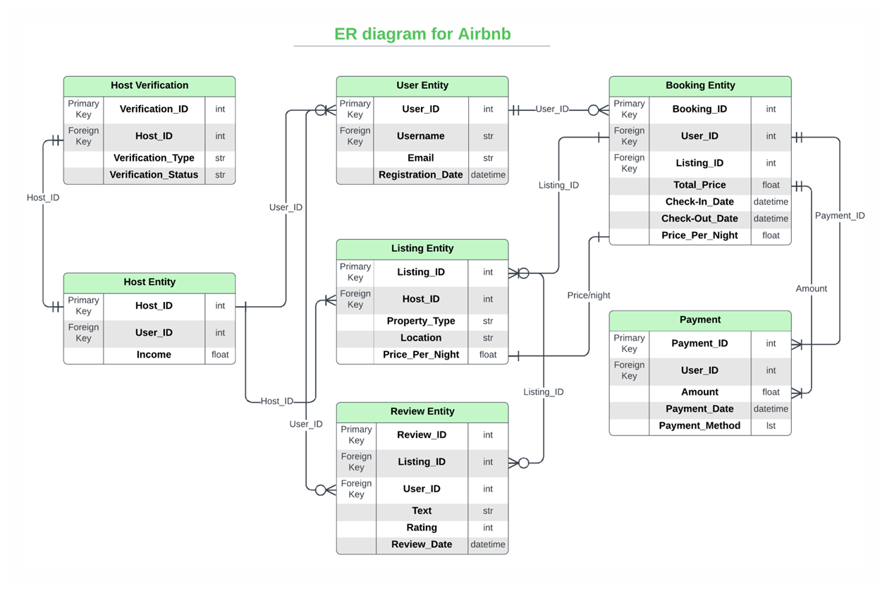

Conclusion

Airbnb's journey from a startup to a global travel and lodging platform is a testament to its ability to identify real-world problems and provide innovative solutions. By offering diverse accommodations, enhancing trust and transparency, providing unique travel experiences, and enabling income generation for hosts, Airbnb has addressed various challenges that users encounter in the travel and lodging industry. This case study showcases how Airbnb's user-centric approach and continuous innovation have positioned it as a disruptor in the travel sector, reshaping the way people travel and find accommodations worldwide.

Video Link:

GitHub repository link: